2-factor authorization for LIB Dokuwiki

There are 2 methods of 2-factor authentication: Google Authenticator or email. The former is already known from Sage, here a token from a second device is used, the latter sends an e-mail to the stored address with the token.
The decision as to which method is used is clear, but can be reset by an admin.
Attention! Every time your own IP address changes, authentication must be repeated (e.g. when switching from a desktop computer to a laptop)
The individual steps:
Before anything else: Log out of Dokuwiki.
- Log in with your user name and password and click on “Login”.
- Now the selection appears, which method you want to use in the future for 2 factor authorization

1st method - Google Authenticator:
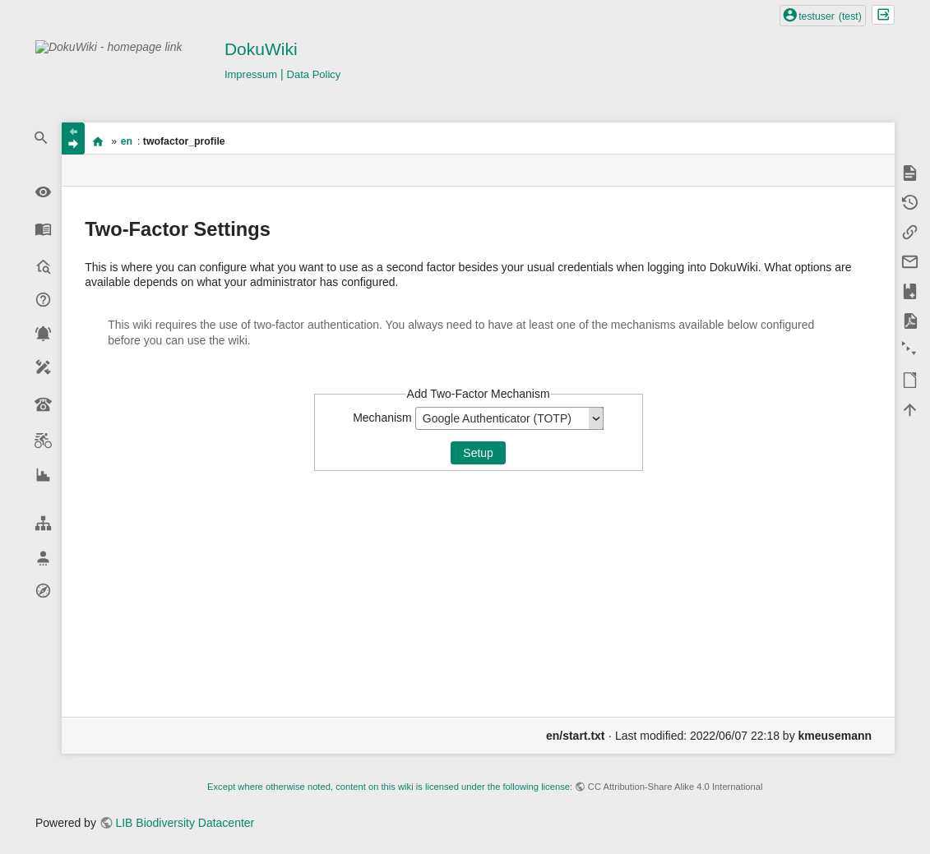
Have the LinOTP app (or the app used for 2FA authentication in Sage) ready on your cell phone.
1.1 A QR code will appear on the next screen. Scan this with the LinOTP app (click on the “+” sign at the bottom right).
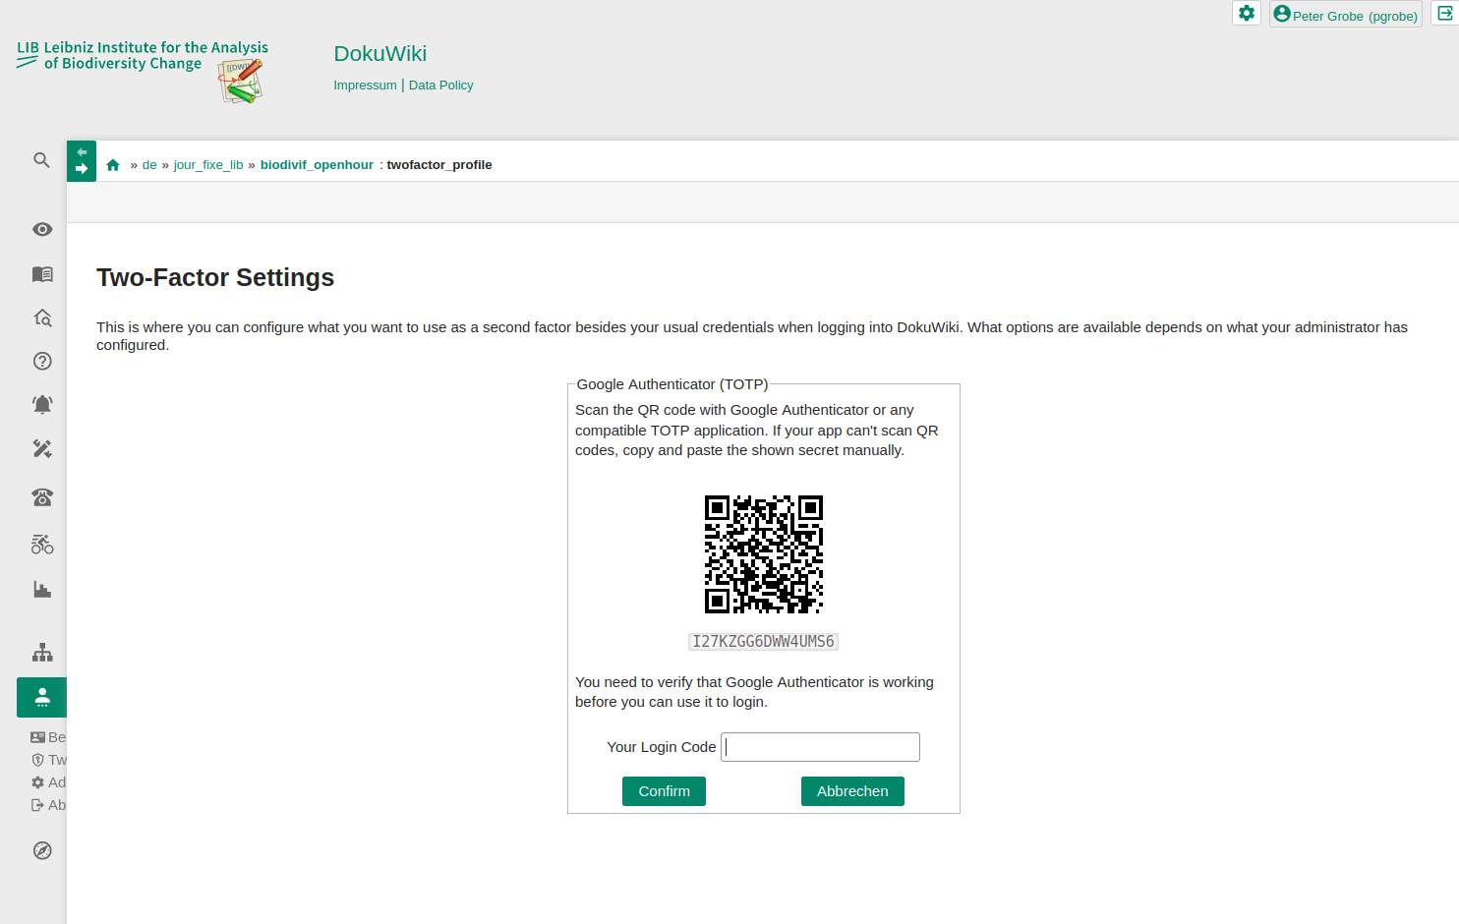

1.2 Enter the first code to pair the devices with each other
1.3 Confirm and enter the second token (possibly renew the token on the cell phone if it has expired).
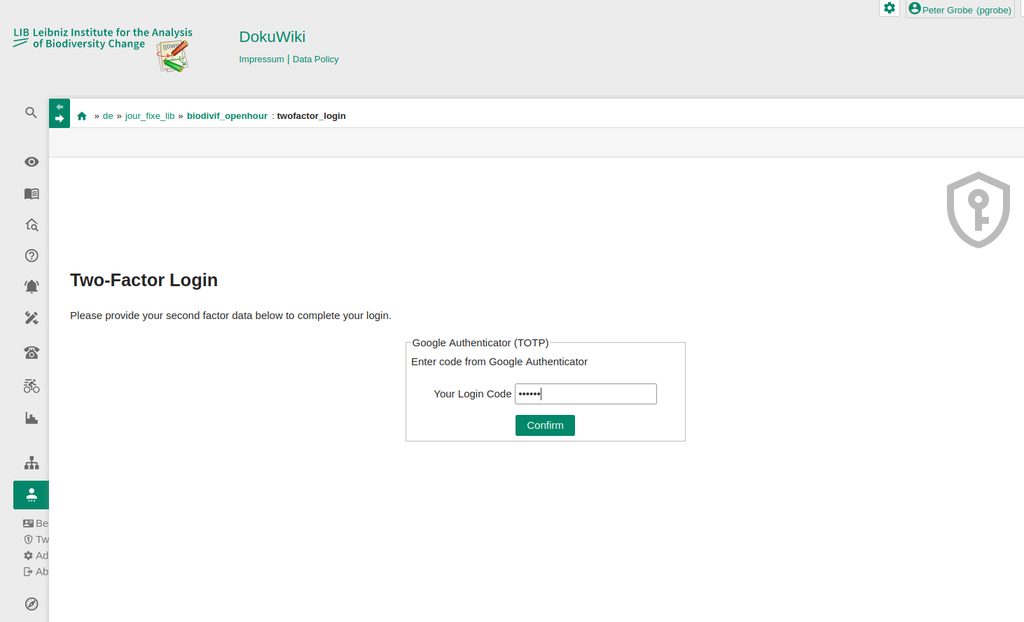

Done.
At the next login only step 1.3 needs to be executed.

2nd method - e-mail:
Open your favorite e-mail program and log in to the LIB account.
2.1 Choose the Email option in the LIB Dokuwiki and click „Setup“:
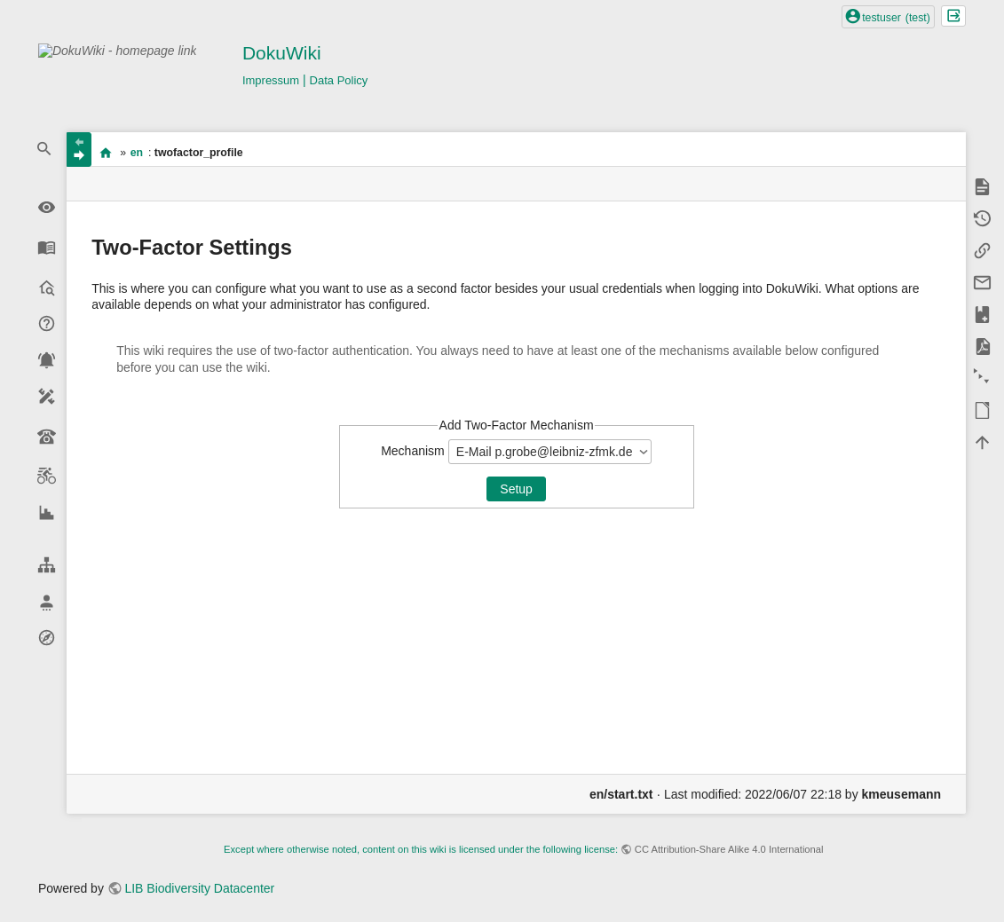

2.2 An e-mail is sent to the saved address:
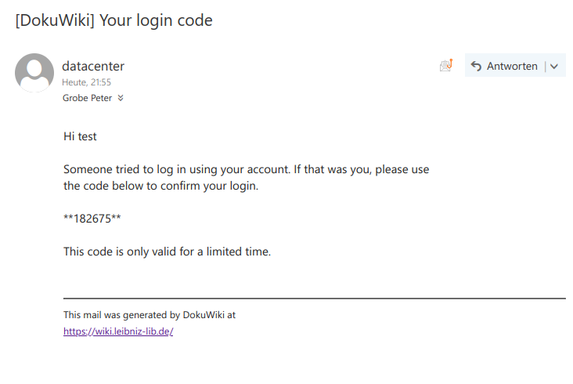

2.3 Enter the token without the surrounding asteriscs specified there and confirm. The e-mail address is now connected to the Authenticator plugin.
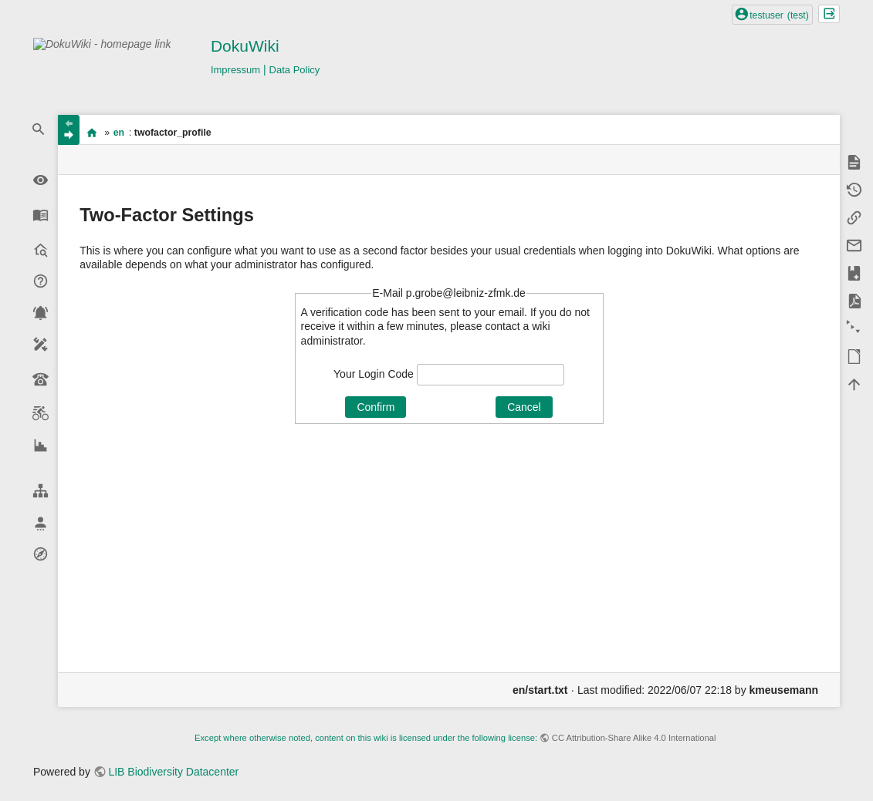

2.4 A second email is sent for authentication. Enter the token contained in the e-mail again and confirm.
Done.
At the next login only step 2.4 needs to be performed.

Change the selected method
You may change the selected Two-Factor method by choosing User Tools → Two-Factor Settings in the navigation bar on the left. By Pressing the Revoke Selected Mechanism-button you will be guided to the setup of the two factor setup again.


